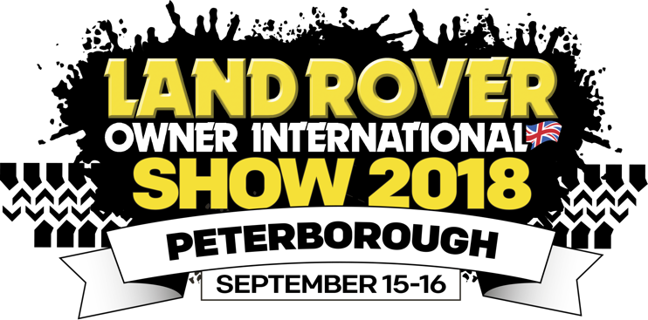
The LRO Show
15- 16 September 2018

Helpful social media tips and content
ready for you to use.

Tag @LandRoverOwner in your tweets and we guarantee that we will retweet you.
Use our hashtag #LROShow to increase your visibility.

Twitter

We’ve booked our tickets to this year’s #LROShow. Have you? Book now @ https://goo.gl/cDpo3k
Less than six weeks to go until #LROShow with @LandRoverOwner – see you there! https://goo.gl/cDpo3k
Excited to be exhibiting at @LandRoverOwner ‘s #LROShow this Sept. Visit us on stand XXX https://goo.gl/cDpo3k
Come and celebrate the iconic Defender with us at #LROShow this Sept. Book tickets @ https://goo.gl/cDpo3k
Final prep underway ahead of our stand @ #LROShow . Hurry –book tickets @ https://goo.gl/cDpo3k

Ever wanted to find out more about being part of a Land Rover club? Head #LROShow this Sept – non-members welcome https://goo.gl/cDpo3k

You don’t have own a #landy to come see us at @LandRoverOwner ‘s show. Enthusiasts (+ friends /family) welcome too! https://goo.gl/cDpo3k
Here’s one of many fantastic products we’ll be showcasing on our stand at the #LROShow (tweet with an image)

Head to the #LROShow this Sept to save 20% on our entire range of XXXX – special offer for show visitors only. (Please include image/link to product range, change the offer as suits)

Live Arena Action, Exhilarating Off-Road Course, Top Retailers + more at #LROShow this Sept! https://goo.gl/j2YnE8

Twitter tips

- If you want to schedule lots of tweets in in advance, one great tool for this is www.hootsuite.com which is very easy to use.
- You can find our Twitter feed at www.twitter.com/LandRoverOwner. Feel free to retweet things that you think your followers will like! We’ll retweet you also!

Facebook

Less than two months to go until the LRO Show!
The Land Rover Owner Show is the UK’s biggest and best Land Rover show of the year. Visitors can expect to see fast-paced laps, high-octane action and a spectacular demonstration course in the Live Action Arena; the widest range of Land Rover clubs representing all models made; and buy everything from state of-the-art off-road equipment to elusive old parts. Come see us on stand XXX at the Peterborough Showground, from 15-16 September! Price ranges from £6 - £90. Dogs are welcome. Get your tickets today: https://goo.gl/dcahT4
(Include images to make your post eye catching)

Save 20% at the LRO Show!
Here’s a look at some of the products that we will be bringing along to the LRO Show this September. Come along and see us on stand XXX to save 20% on everything! Book your tickets now at https://goo.gl/dcahT4
(include album of your product images, change the offer as suits)

Go off-road at the LRO Show!
Are you someone who likes to go off the beaten track from time to time? Well then the Land Rover Owner International Show might be just the event for you! Visitors to this event can venture off-road into the toughest of obstacles, conquering the steepest of hills and muddiest of gullies! Whether you are an owner or just an enthusiast, you won’t be disappointed with what this show has to offer. Plus, we’ll be there too! Book tickets at: https://goo.gl/dcahT4

Facebook tips
- Facebook has a scheduling tool. You’ll find it in the drop down menu next to the publish button below where you enter your status update
- You can tag our page in your posts, so that your followers can easily find more information about the event. To do so type @LandRoverOwner

Website event listing

The Land Rover Owner Show on 15-16 September at the Peterborough Showground is the UK’s biggest and best Land Rover show of the year. Visitors can expect to see fast-paced laps, high-octane action and a spectacular demonstration course day and night in the Live Action Arena; the widest range of Land Rover and Range Rover clubs representing all models made; and buy everything from state of-the-art off-road equipment to elusive old parts. Have a go on our 4x4 off-road course, listen to live music, watch a live vehicle rebuild, take advantage of our Happy Hour bar, browse hundreds of shopping stalls and with plenty of activities thrown in for the kids too, it’s going to be one almighty Land Rover party!

With great camping facilities, why not make a weekend out of it? Price ranges from £6 - £90. Dogs are welcome. For more information, visit www.lroshow.com

